Containers

- Verify Docker installation:
docker --version
docker run hello-world
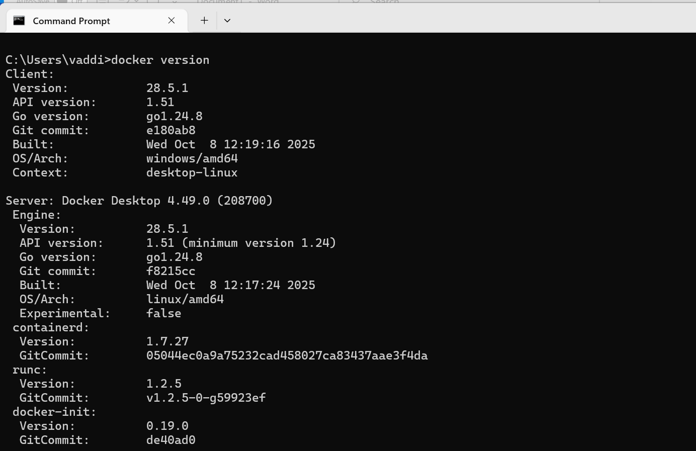
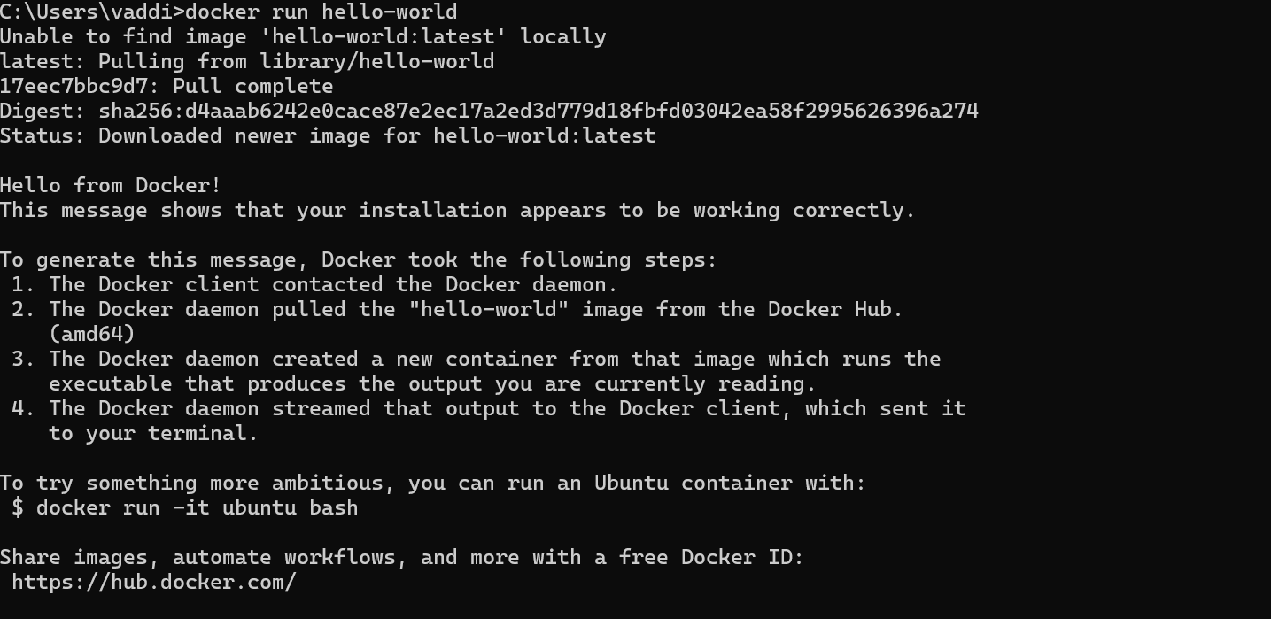

2.Run an Nginx web server container:
docker run -d -p 8080:80 nginx
Visit http://localhost:8080 to confirm.
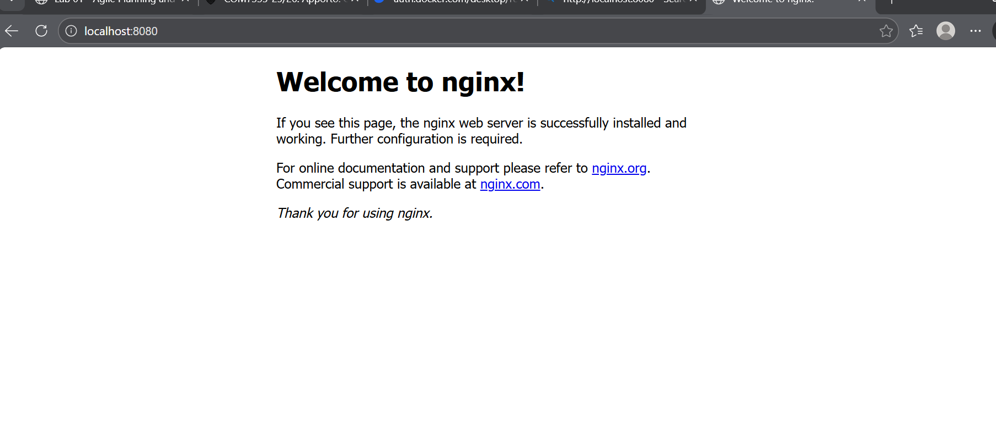
- Inspect the container environment:
docker ps
docker exec -it <container_id> uname -a
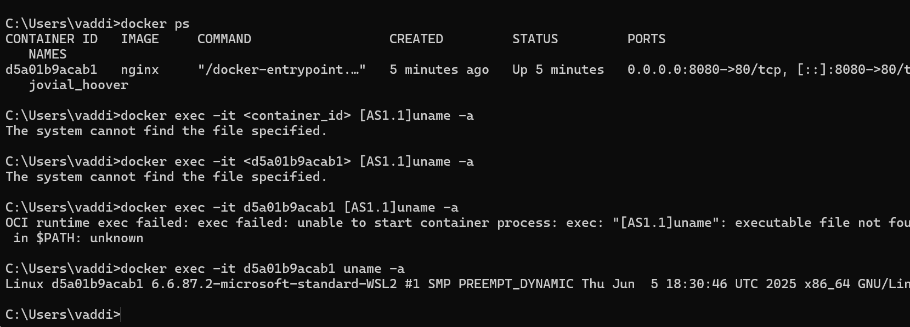
The Container is running on the Linux OS where my system OS is windows

Part 2: Building Your Own Portable Container

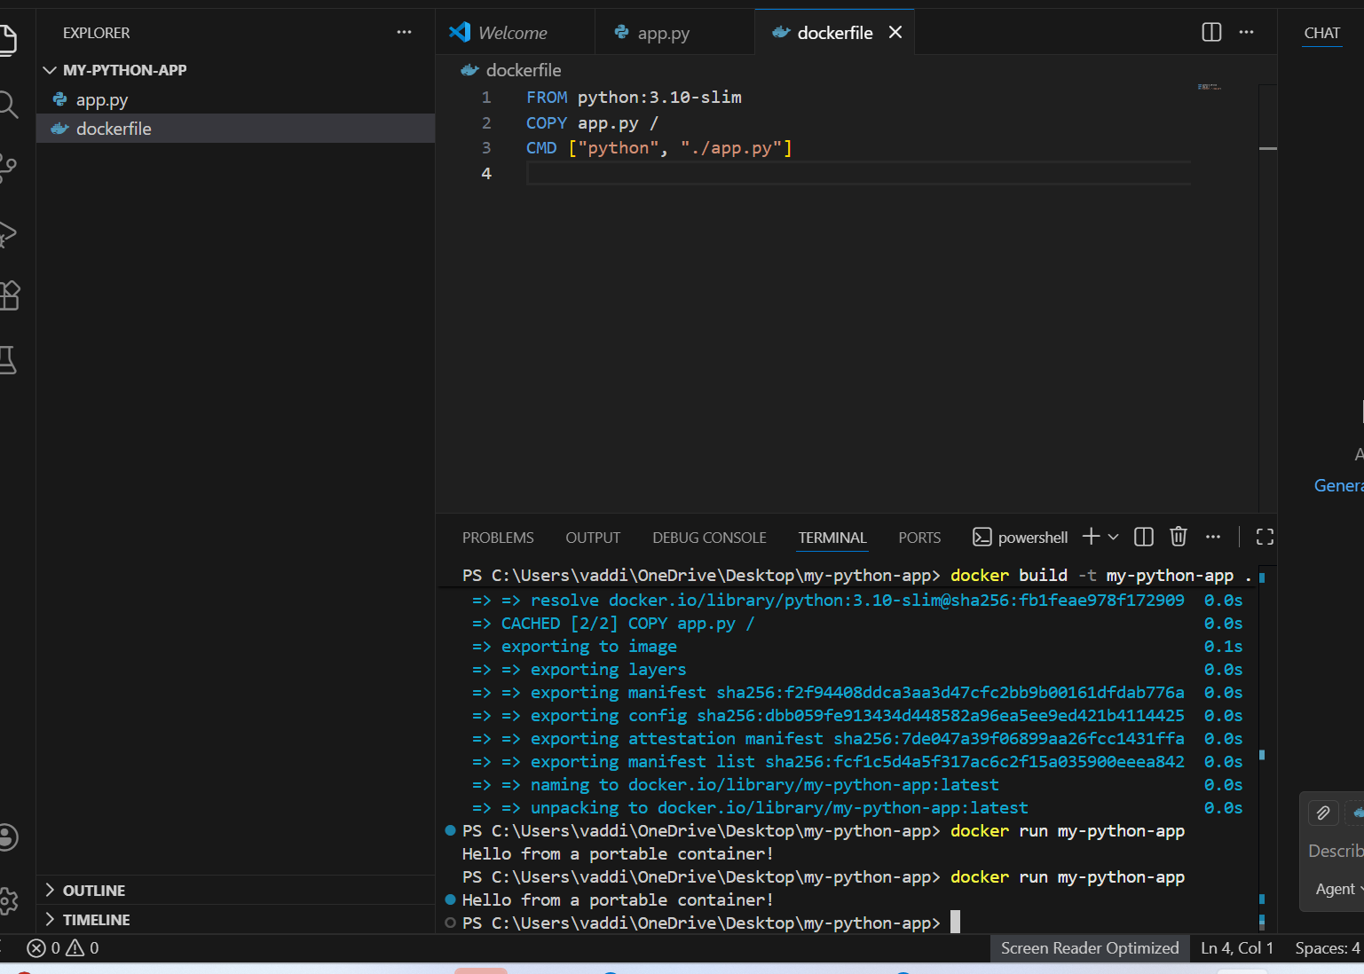
docker save my-python-app > my-python-app.tar
Test portability by loading it on another system (if available).
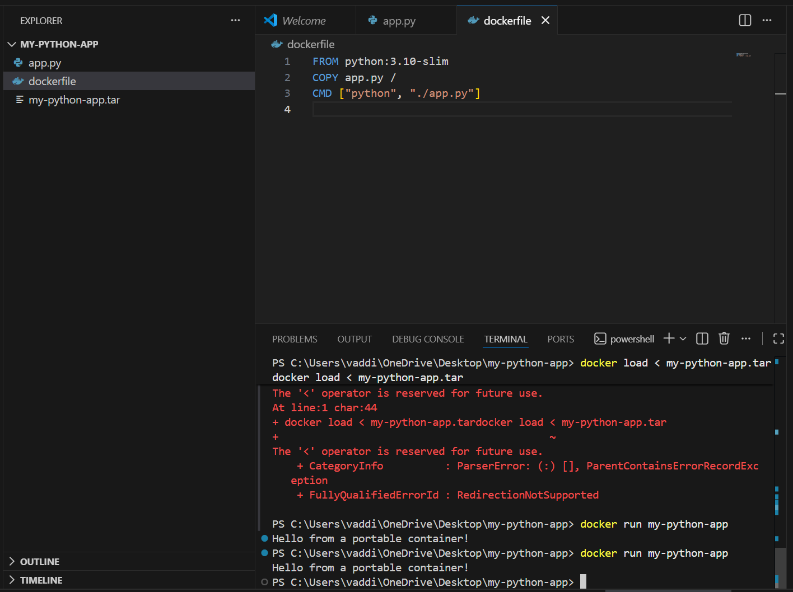

Part 3: Scaling and Managing Containers
- Run multiple instances of your app:
docker run -d --name app1 my-python-app
docker run -d --name app2 my-python-app
docker ps
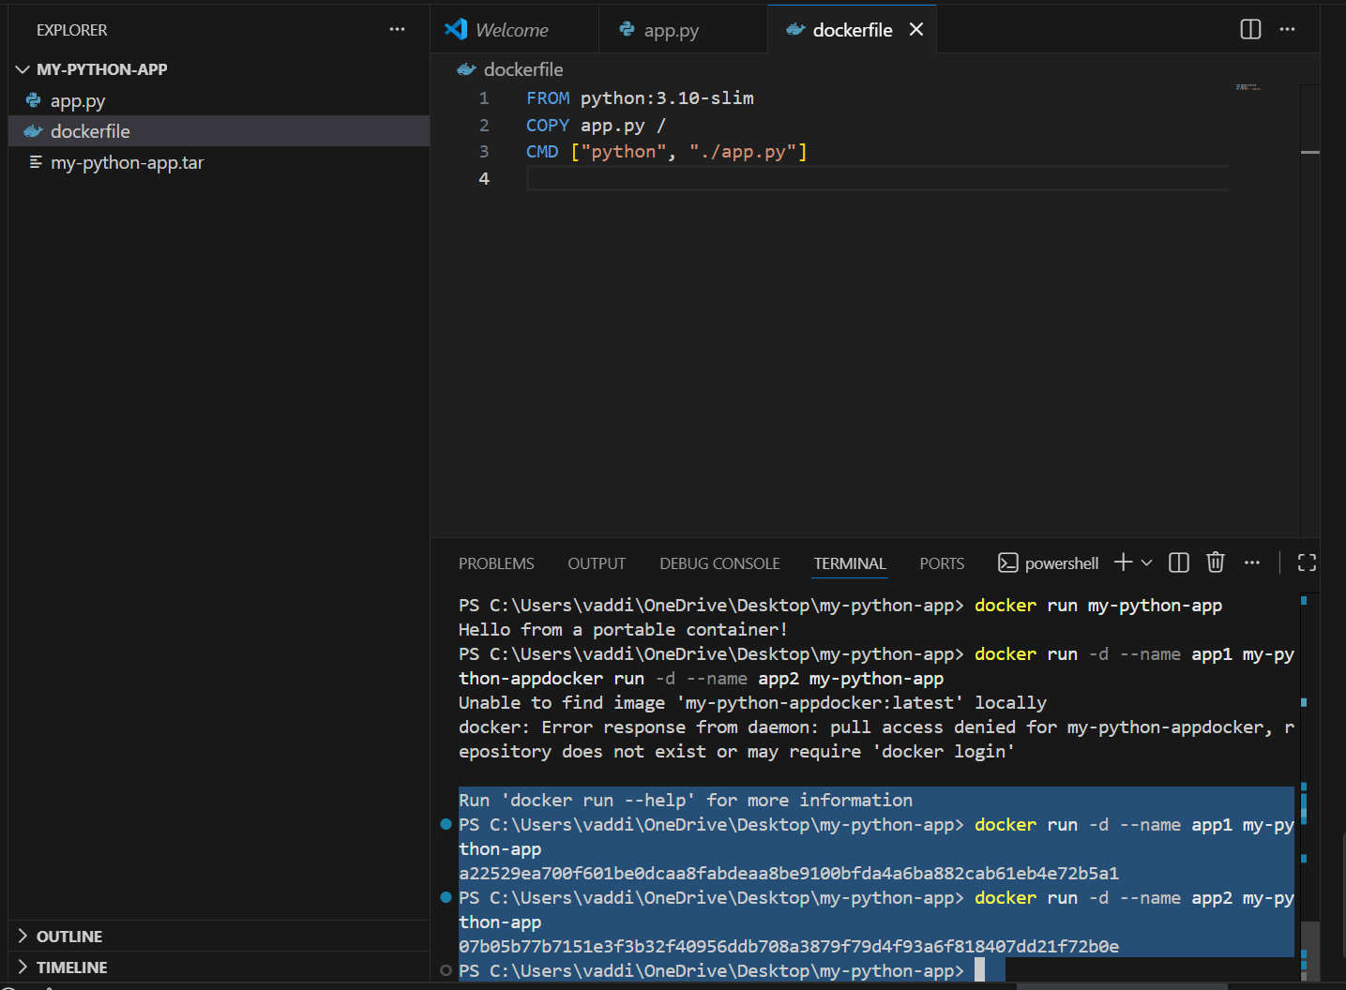

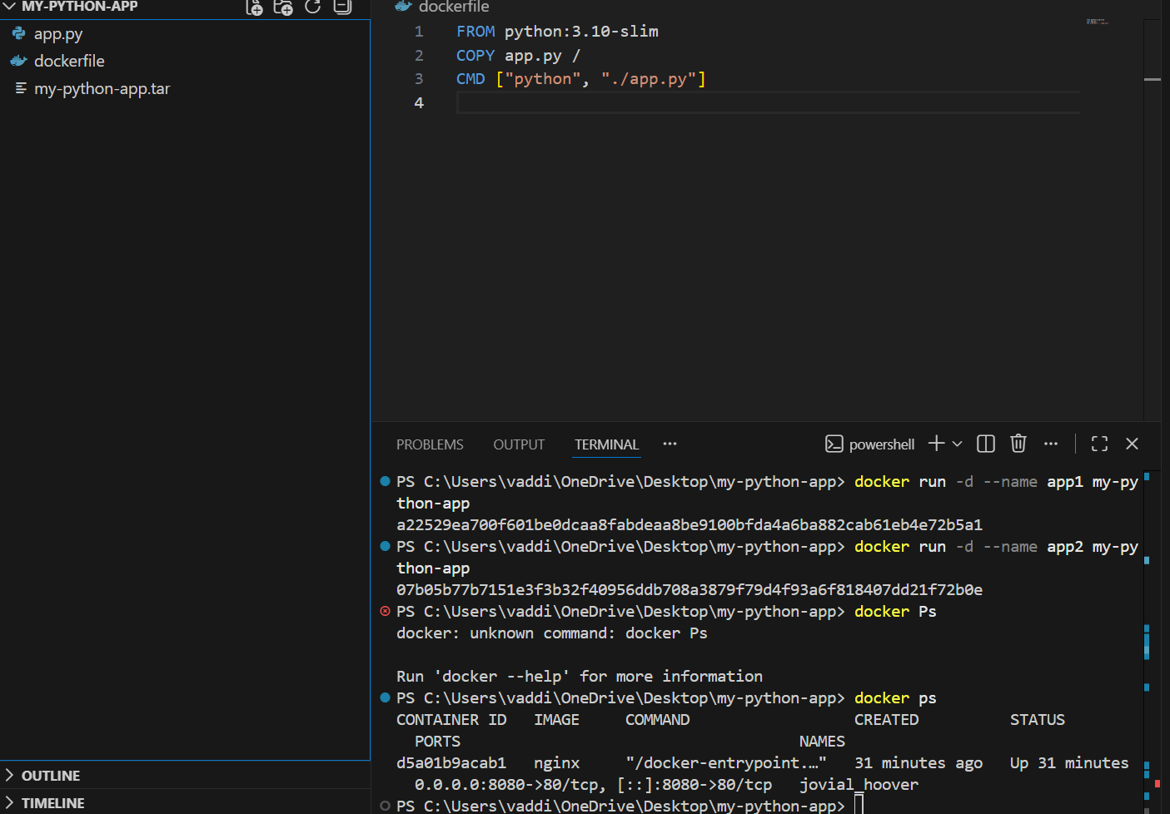

- Stop and remove containers:
docker stop app1 app2
docker rm app1 app2
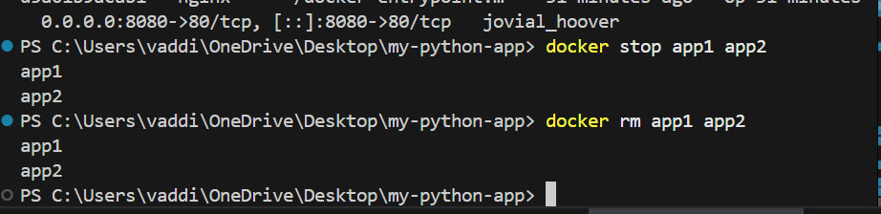
This demonstrates scalability — multiple instances can run independently without conflict.

Part 4: Networking Between Containers
- Create a user-defined network:
docker network create my-network
- Run a backend container:
docker run -d --name backend --network my-network nginx
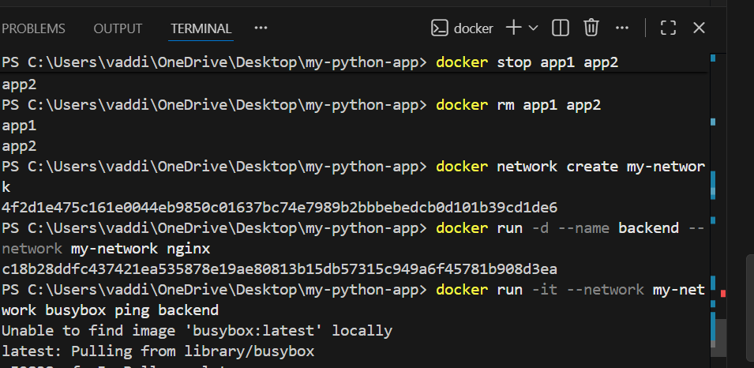
3.Run another container on the same network and test connectivity:
docker run -it --network my-network busybox ping backend
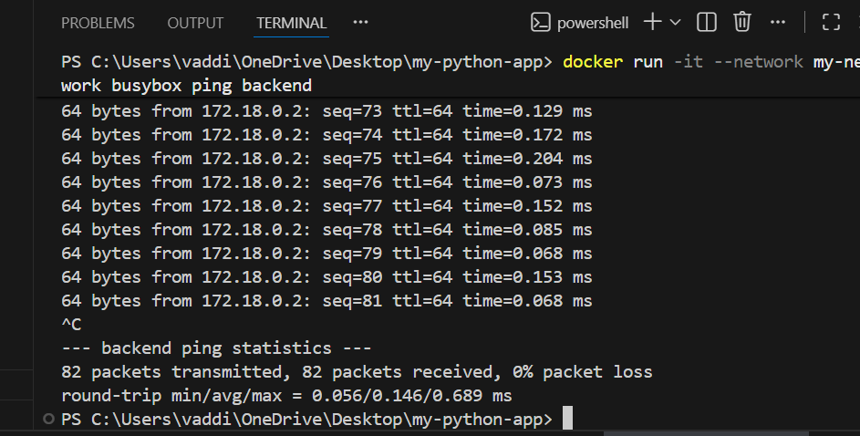

Part 5: Connecting to the Cloud (Optional Challenge)
Push your image to Docker Hub for future deployment in a cloud environment.
docker tag my-python-app <dockerhub_username>/my-python-app:v1
docker login
docker push <dockerhub_username>/my-python-app:v1
